Further legal action looming over Ruataniwha Dam
2:29 pm on 28 September 2016

Copyright © 2016, Radio New Zealand

The Hawke's Bay Regional Council's investment arm is joining the Department of Conservation (DOC) in seeking an appeal to the Supreme Court over a decision relating to a land exchange for the Ruataniwha Dam.
The council wants to dam 22ha of formerly-protected land, flood it and give the department 170ha of nearby farmland in return.
The Court of Appeal ruled last month the process of acquiring the protected conservation land for the $900 million irrigation scheme was unlawful and ordered the Director-General of Conservation to reconsider his decision on the land swap.

That hearing took place after Forest & Bird appealed against a High Court decision upholding the land swap.
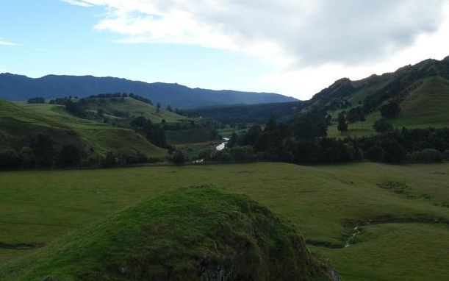
The proposed Ruataniwha Dam would be built on this site in Hawke's Bay. Photo: RNZ / Peter Fowler
Hawke's Bay Regional Investment Company (HBRIC) chairman Andy Pearce said the project would bring several benefits to the community.
"There is a strong commitment from HBRIC, and those involved, to deliver the Ruataniwha Water Storage Scheme and its wide-ranging environmental, social and economic benefits."
Mr Pearce said his organisation would join DOC in applying for an urgent hearing in the Supreme Court to seek leave to appeal against the Court of Appeal's decision.

Land swap could set precedent - Forest & Bird
Forest & Bird acting chief executive Mike Kotlyar said many New Zealanders would be baffled by the Department of Conservation's legal bid to try and overturn the Court of Appeal decision.
"The ultimate outcome sought by this challenge is to enable the controversial Ruataniwha Dam to proceed.
"We doubt New Zealanders would consider it to be the Conservation Minister's role to support irrigation schemes like this.
"If it goes ahead, this land swap will set a precedent for up to one million hectares of specially protected conservation land, creating the possibility that these areas can be reclassified and destroyed."
Forest & Bird said the land that would be swapped would include mature forest that was home to threatened wildlife, including long-tailed bats and falcons.

Ruataniwha land-swap to be appealed in Supreme Court

Dec 13, 2016:
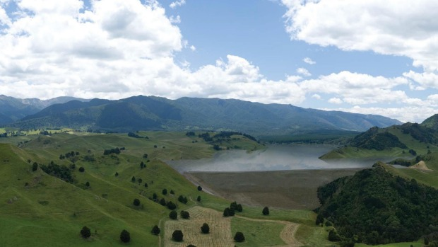
SUPPLIED
An artist's impression of the 7km-long lake that would be created as part of the Ruataniwha water storage scheme in Central Hawke's Bay.
The decision to stop the $330 million Ruataniwha dam project going ahead on a block of conservation land in Hawke's Bay will be appealed in the Supreme Court.
The Department of Conservation (DOC) and the regional council-owned Hawke's Bay Regional Investment Company (HBRIC) sought the hearing after the Court of Appeal thwarted a land-swap deal pivotal to the creation of a 7km-long irrigation reservoir in the foothills of the Ruahine Range.
HBRIC wants to dam the Makaroro River to create the reservoir, using the water to irrigate more than 25,000 hectares of drought-prone farming and cropping land in Central Hawke's Bay.
DOC's appeal will be heard in the Supreme Court in Wellington, possibly in February.
But its plans were stalled because 22ha of the land it wants to flood is protected with special conservation status.
HBRIC offered to swap the block for 170ha of nearby farmland, but DOC's process for approving the swap was successfully challenged by Forest & Bird in the Court of Appeal.
Forest & Bird lawyer Sally Gepp encouraged Conservation Minister Maggie Barry to reconsider her priorities and stand up for conservation lands against commercial interests.
"We look forward to the defending New Zealand's protected land in court should she continue backing the corporate agenda over publicly owned land.
"We also understand that Hawke's Bay Regional Council are voting on a dam moratorium proposal tomorrow, and we will be interested to see if they take the opportunity to instruct HBRIC to withdraw from court proceedings."
Barry had previously backed her department's decision to seek leave to appeal to the Supreme Court.
Acting Chief Executive of HBRIC, Blair O'Keeffe, said it "is a positive development".
The Supreme Court has indicated it will hold a two-day hearing in February 2017.
- Stuff

