Should we charge for NZ's great walks?
From Jesse Mulligan, 1–4pm, 1:33 pm on 28 October 2016

Increased tourist numbers on the country's great walks has prompted DOC director general Lou Sansom to raise the possibility of charging to use them.
Sanson talked about the about the explosion in popularity of the treks all over New Zealand at a Queenstown Chamber of Commerce meeting.
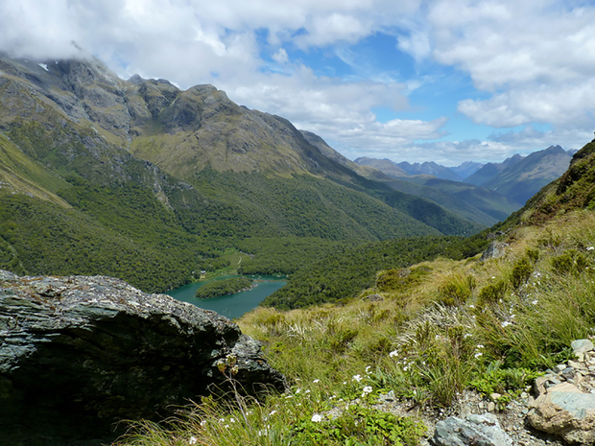
Photo: Department of Conservation
Listen to Robin McNeill talk with Jesse Mulligan duration7′ :53″
He said current legislation does not allow DOC to charge for entry to national parks it can only charge for the use of the facilities they provide.
But past president of Federated Mountain Clubs of New Zealand Robin McNeill says it is a complex problem and does not believe charging is the way to go.
“I wouldn’t actually change, you’ve always got to be careful what you wish for. Another way of looking at the whole thing, and perhaps Lou and I are of different views here, if there’s 18 percent growth in tourists to NZ why not invest more in the product?”
He says New Zealand spends a large amount of money marketing itself, and tourist numbers are growing exponentially, so more of the revenue that flows from that should go into the back country.
McNeill says determining who is a tourist, and who a short-term resident or worker could be difficult, and the overheads of administering the charge could soak much of the revenue generated.

The price of paradise: New Zealand's Great Walks are losing millions of dollars
JONATHAN CARSON
Stuff
Last updated 16:11, November 25 2016
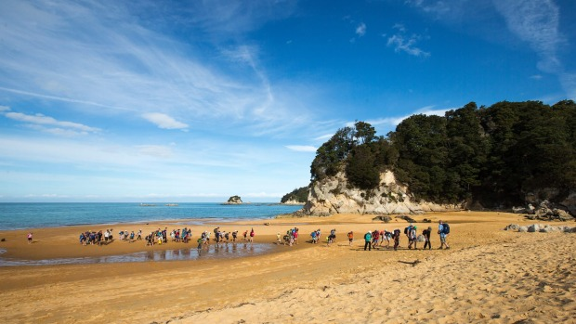
VIRGINIA WOOLF
Visitors arriving off the water taxis walk across the beach at Kaiteriteri, Abel Tasman National Park.
New Zealand's Great Walks are operating at a multi-million dollar loss, prompting renewed calls for the Government to make visitors pick up the cost.
In the last financial year, more than 117,000 people visited New Zealand's Great Walks – a 12 per cent increase on the previous year – and 60 per cent of those were international tourists.
Despite the increasing popularity of New Zealand's national parks providing more revenue, the eight Great Walks managed by DOC lost more than $3 million in the last financial year.
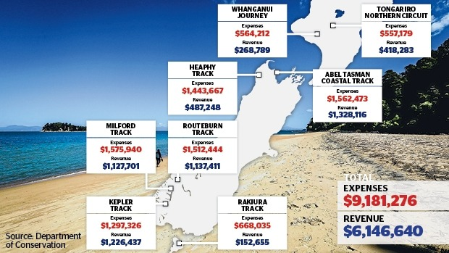
The revenue and expenses for each of the eight Great Walks managed by the Department of Conservation in the year to March.
The Heaphy Track – from Collingwood in Golden Bay to Karamea on the West Coast – alone had a deficit of more than $950,000.
The Kepler Track in Te Anau was the closest to breaking even, but was still more than $70,000 in the red.
Even the country's most popular Great Walk, the Abel Tasman Coastal Track, with 42,105 visitors in the last financial year, lost more than $230,000.
That some of New Zealand's most popular and valuable tourist attractions are leaking taxpayer money has renewed calls to plug the funding shortfall and make international visitors pay.
Currently, visitors to Great Walks pay between $22 and $54 a night to stay in huts and less than $20 for a campsite. But they don't have to pay an entry fee.
Darryl Wilson, chief executive of Motueka-based tour operator Wilsons Abel Tasman, said he supported the idea of charging visitors to use Great Walks, saying it would be a "positive contribution to restoration and rehabilitation" of the conservation areas.
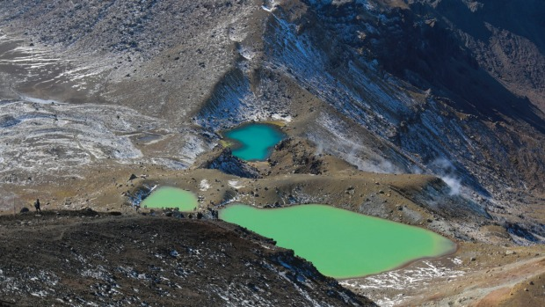
Rebekah Parsons-King/Fairfax NZ
The Tongariro Northern Circuit had 8596 visitors in the year to March - 64 per cent of those were from overseas.
He said commercial operators paid a "raft of fees" that independent visitors did not.
"There is obviously a precedent just about everywhere else in the world. People expect it. I've never gone 10 kilometres from Uluru National Park and gone, 'Oh no, I'm not going to go in there, it's going to cost me $20 a day'."
In places like Patagonia in southern Chile, tourists pay about $55 NZD to enter the famous Torres del Paine National Park.
In the United States, they have the annual America The Beautiful pass, which costs $114 NZD and lets people access national parks and federal recreational lands.
West Coast Tasman Labour MP Damien O'Connor said he supported a levy for international visitors. Charging tourists about $25 each at the border would generate close to $100 million a year, he said.
"That would be available for all tourism infrastructure, including the Department of Conservation facilities."
He said charging visitors a separate fee to access national parks and Great Walks would be "ad hoc, mess and probably inefficient".
"There's a risk that if we set up something like that the bureaucracy itself would cost more than the direct benefits to the department.
"We should see ourselves as one big national park as a country, and coming into the country was the place that you pay your fee and we retain, I guess, the freedom that most visitors currently have."
Last month, DOC director-general Lou Sanson said introducing a "differential charge" for international and domestic visitors was an option.
DOC director recreation, tourism and historic, Gavin Walker, said Great Walks weren't designed to make money but the recent surge in visitors has highlighted the need to "examine whether the current approach remains appropriate".
Since DOC partnered with Air New Zealand three years ago, there had been a 31 per cent increase in overnight hut and campsite stays on Great Walks, Walker said.
Conservation minister Maggie Barry said DOC was working with the tourism industry and other stakeholders to explore options for more sustainable funding.
"No decisions have been made, but a number are being considered, such as differential fees for international and domestic visitors."
She said legislation currently precluded DOC from charging for access to national parks and walks.
Barry said the Government was waiting for the results of a private sector review of a tourist levy. A decision would likely be made before next year's election, she said.
Green Party conservation spokeswoman Mojo Mathers said DOC was "severely underfunded" and the first step to addressing the Great Walks shortfall was to increase the department's budget.
"Since the last Labour government, DOC has had to endure $336 million less in funding," she said.
"We're deeply concerned about the effect that underfunding has on all parts of the work DOC does, not just Great Walks.

Should NZ's Great Walks be privately-run?
5:21 pm on 12 December 2016

RNZ

Tim Graham Reporter tim.graham@radionz.co.nz

A new report from four of New Zealand's tourism leaders moots the possibility of privatising the country's Great Walks.
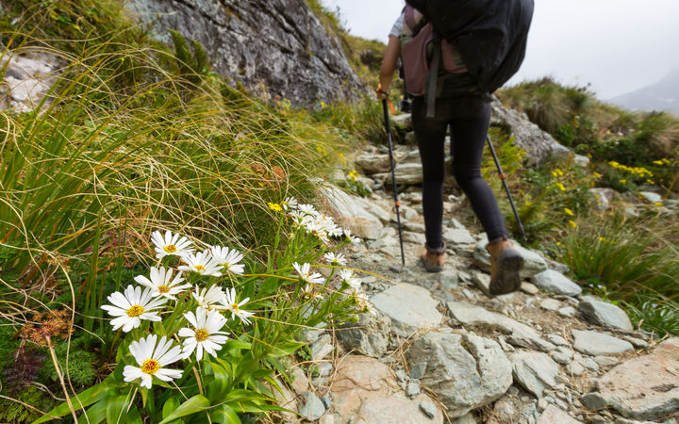
The Routeburn Track is among New Zealand's eight Great Walks (nine including the Whanganui River paddling trip). Photo: 123rf / Naruedom Yaempongsa
The controversial suggestion is one of a raft of proposals contained in the Tourism Infrastructure Study, commissioned by the heads of Air New Zealand, Auckland Airport, Christchurch Airport and Tourism Holdings.
"It's just bringing some greater commercial discipline" - Tourism Holdings chief executive Grant Webster duration28′ :50″
from Nine To Noon

The eight Great Walks managed by the Department of Conservation (DOC) lost more than $3 million in the last financial year, despite a 12 percent increase on the previous year in visitor numbers.
DOC huts on the routes are already available, subject to a fee, but there is also some accommodation run by private operators.
The report said the model of working with the private sector was strong, and had more potential.
"The model could be logically extended to differentiated pricing for access to iconic scenic sites for international tourists, and working with private providers to develop commercial models for a wider range of infrastructure."
This could happen without sacrificing the public right to access to the conservation estate, it said.
Tourism Holdings chief executive Grant Webster told Nine to Noon there was room to bring more commercial rigour to how the walks were operated.
"It's just bringing some greater commercial discipline, is our suggestion in that place. We haven't invested the time and effort in this just for it to be put on a table somewhere. We're very keen to continue to work with government to try to get these philosophies in place. We believe in them."
But Dave Hammond, a tourism consultant and the former chief executive of the Thames-Coromandel District Council, was sceptical.
"I think that's a straw man. New Zealand being what it is, we've got quite a strong historic commitment to free open spaces and also Treaty of Waitangi issues.
"I've been dealing with Cathedral Cove for a while, and that's been a partnership between local government, DOC, local iwi and local community - and those are the types of parties you need to put around issues like this."
Federated Mountain Clubs spokesperson Robin McNeill was also dubious.
"Why not charge access to beaches while you're at it? There's no real difference. In fact, if you were to charge for access to national parks, then you would be charging for access to beaches, because all of Lake Te Anau is in the national park."
Conservation Minister Maggie Barry said the government would consider the report, and the range of ideas it raised, but no decisions had been made at this stage.
She has previously said DOC was working with the tourism industry and others to explore options for sustainable funding.
Her office said the ideas being considered included different fees for international and domestic visitors.

The Great Walks - prices for DOC huts (per adult per night):
Lake Waikaremoana ($32), Tongariro Northern Circuit ($32), Abel Tasman Coast Track ($32), Heaphy Track ($32), Routeburn Track ($54), Kepler Track ($54), Milford Track ($54), Rakiura Track ($22) Source: DOC

