DoC 'deep in the doldrums'
Save
Thursday, 06 August 2015
EmailFacebookTwitterGoogle+
The New Zealand Herald
FacebookTwitterGoogle+
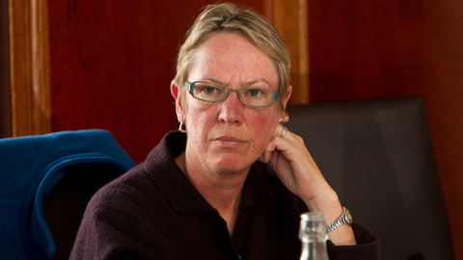
Labour's conservation spokeswoman Ruth Dyson said the survey "shows that the problems go deep within the organisation." Photo / Glenn Taylor
By Nicholas Jones
The Department of Conservation is "deep in the doldrums", Labour says - as a leaked survey show staff lack confidence in senior managers.
Only one in four staff believe DoC has a clear vision of where it is going, an engagement survey leaked to Labour shows, and 27 per cent of staff surveyed have confidence in senior leadership.
Fewer than 30 per cent of staff believe the department delivers on its promises, and just 32 per cent agreed that changes were being made to ensure the department is successful in the future.
Positives included 84 per cent of those surveyed agreeing that their colleagues work together to get work done, and that their immediate boss treats people with respect.
The department has acknowledged that the "entirely predictable" results show more needs to be done to provide "clarity, accountability and leadership" - but also points to positives including that staff remain committed to the organisation.
A new leadership programme and other changes are being implemented, it says.
Labour's conservation spokeswoman Ruth Dyson said DoC was in the doldrums and a major restructuring of the department carried out two years ago had "turned out to be an expensive disaster".
DoC restructured in late 2013, cutting positions as it aimed to "do more with less'' money by encouraging business and the public to take part in conservation work.
An independent review last September, which included a staff survey, said the restructure led to a breakdown in communication and leadership problems, among other issues.
"DoC is now scrambling to repair the damage. But this survey shows that the problems go deep within the organisation," Ms Dyson said.
"Just over half the staff feel a sense of belonging to DoC. And only one third say there is a common purpose, the same number who feel they are working for a successful organisation."
Director general of conservation Lou Sanson said the results from the staff survey "were entirely predictable".
"We've just been through the biggest change to the organisation in 25 years and the biggest change to the public sector. We're really focused on a culture where we trust others, we're performance focused and we're agile."
Mr Sanson said the concerns of staff mirrored those expressed in a survey DoC commissioned late last year.
"The results show that staff remain committed to the organisation but they're also frustrated by some of the ways we work and they want more clarity, accountability and leadership," Mr Sanson said.
"I acknowledge that and that's why DoC is starting to roll out a new internal leadership programme and new ways of working across the organisation."
The recent survey showed that staff in a region where a pilot programme has been running had a much better idea of what work they were expected to do, and who was accountable for decisions, Mr Sanson said.
DoC's senior leadership team were now working on how lessons from that pilot can be spread across the entire department.
Conservation Minister Maggie Barry also pointed to the success of the Nelson pilot programme.
"I have absolute confidence in Lou Sanson and his refreshed leadership team's ability to address any issues DoC might have had.
"It is an organisation valued by New Zealanders, as shown by the Randstad Award it received for most attractive employer in March."

